Tracheostomy Study guide
The George Washington University Hospital
Professional Development and Education

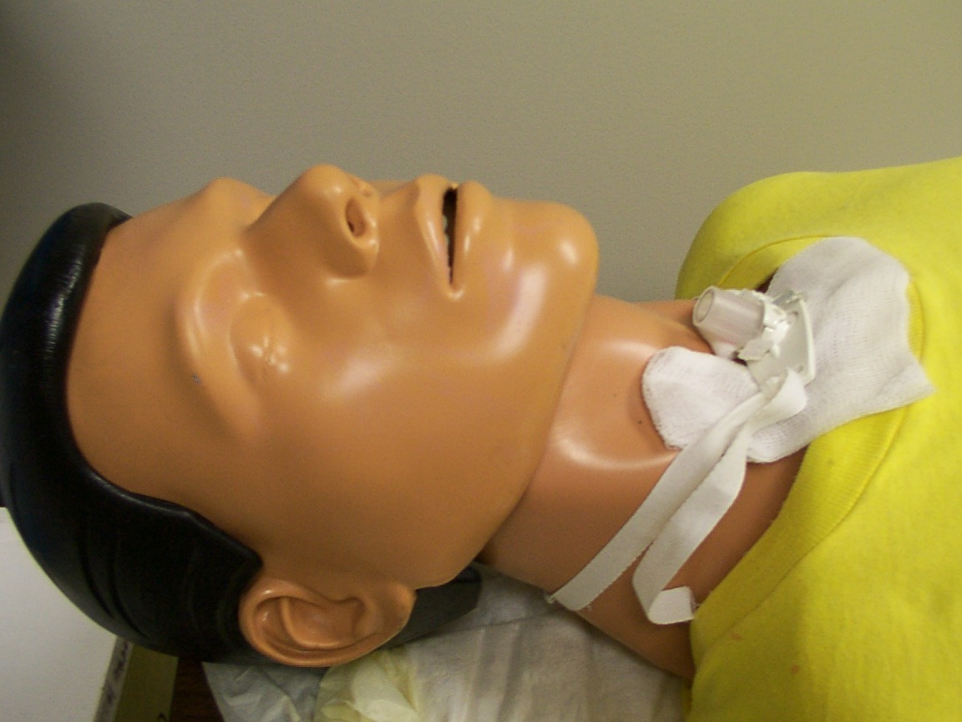

Noreen Westfall RN, BSN, CMSRN
Hospital Education Coordinator

Chapter 1
Anatomy and Physiology Upper Airway 3
Larynx 4
Trachea 5
Tracheostomy : Surgical 6
Tracheostomy : Percutaneous 7
Post – Tracheostomy Complications 8
The role of the Cuff 9
Cuff inflation/deflation 10
Signs/symptoms of cuff leakage 11
Fenestrated Tracheostomy Tube 11
Types of Tracheostomy Tubes 12
Tracheostomy Tube Accessories 13
Think Trach Care 15
Indications for Suctioning 15
Complications Related to Suctioning 16
S/Sx of Airway Obstruction 16
Tracheostomy Orders 17
Documenting on Trach Documentation 17
Form
Evaluating need to suction 17
Trach Care 17
Changing Ties 19
Plan to be prepared 20
Educate 20
Terminology 21
Attachments
Physician Order Sheet
Trach Documentation Form

Anatomy and Physiology
Chapter
1
Upper Airway and Trachea
The Upper Airway
the nose plays a very important role in the upper airway. As air enters the nostrils large particles of dust and dirt are filtered. The mucous membranes of the nasopharynx further filter this air, warm or cool the inspired air, and humidify it.
The column of inspired air travels through the oral pharynx to the laryngopharynx. Here it passes through the larynx where the vocal cords are located. The larynx is located at the top of the trachea. When a person breathes in, the vocal cords open, allowing air to pass freely into the trachea.

.

Larynx

The larynx is composed of nine cartilage structures
- Three large Single Cartilages
- Epiglottis
- Thyroid
- Cricoid
- Three Paired Cartilage
- Arytenoids
- Cuneiforms
- Corniculates
The cricoid cartilage is the only circumferential cartilage of the trachea. This is an important landmark used during tracheostomy.

Trachea
The trachea is a tubular structure. It extends from the larynx through the neck to the thorax (10 – 14 cm in length).
The trachea terminates at the carina and bifurcates into the left and right main stem bronchi.
Within the thorax the trachea lies in the mediastinum, its lower position is directly behind the heart and large vessels.

Indications for Tracheostomy
There are usually four main goals. The procedure may be done to achieve a combination of the following goals.

- Patent airway
- Protects lungs from obstruction or aspiration
- Removal of secretions
- Long term ventilatory support
When compared to an endotracheal tube, tracheostomy tubes are considered more beneficial in that they:
- Prevent further laryngeal injury from translaryngeal tube
  - Improve patient comfort
  - Decrease work of breathing
  - Provision of speech mechanism
  - Increase patient mobility

Tracheostomy
An incision is usually made at the 2nd, 3rd or 4th tracheal cartilage.
During insertion of the Tracheostomy tube, the obturator replaces the inner cannula. Its smooth surface protrudes from the outer cannula, minimizing tracheal trauma. Once the tracheostomy tube is inserted, the obturator is removed and replaced with an inner cannula. Make sure the inner cannula is locked in place.
- The obturator should be placed in a plastic bag and kept at the bedside in case the tube needs to be reinserted emergently.

Tracheostomy

Usually tracheostomy is performed as a surgical procedure. However, there is a procedure known as Percutaneous tracheostomy that is performed at the bedside. This procedure consists of passing a J-tipped guide wire and placing the tracheostomy tube.
Post-Tracheostomy Complications
There are two ways to categorize complications. Immediate surgical complications and late complications
- Hemorrhage
Massive bleeding may occur a few days to several weeks post–op. Delayed hemorrhage may be due to erosion of the tracheal wall. The tip of the tube may then perforate a major blood vessel usually the innominate artery.
- Wound Infections
Infection at the tracheostomy site may be minor and respond to local treatment. Serious mediastinus can result from an untreated tracheostomy wound infection.
- Tracheitis
A dry tracheitis will develop if humidification of the airway is inadequate. Secondary infections may require treatment with antibiotics.
- Pneumonia
Aseptic technique during surgery and trach care including suctioning can prevent pneumonia or lung abscess. Please use sterile suction catheter or closed suction system to avoid bacterial invasion of respiratory system.
- Subglottic edema
Usually associated with infants and children when the incision is made via the 1st or 2nd tracheal cartilage. Edema of the subglottic area may develop. The swelling of the mucosa will restrict the airway above the tube and can be difficult to decannulate the patient.
- Tracheal stenosis
This is the narrowing of the trachea by stenotic grannula tissue (scar tissue). This narrowing can occur at the : Tracheal opening Cuff site Position of tube tip
- Tracheoesophageal Fistula
The posterior wall of the trachea erodes into the underlying esophagus. This complication is rare but if it occurs it is potentially fatal.
Monitoring cuff volumes and having a properly sized trach tube helps to decrease this incident.
Tracheal stenosis at the cuff site can be avoided by using a trach tube with a low volume cuff and monitoring the cuff pressure. Erosion of the tip of the wall can be decreased by tube used (proper length, size and curvature). Many tubes now soften slightly with the patient’s body temperature, which allows the tube to conform to the patient’s trachea. Movable neck plates also help in the process for the tube to conform to the trachea
Some Trachs Have It …Some Don’t ….The role of the Cuff
A cuffed tube is appropriate for patients who require mechanical ventilation or when aspiration is a problem. The cuff prevents or limits aspiration of oral and gastric secretions. Uncuffed tubes are commonly used in children, adult patients with laryngectomies, and during decannulization of the tracheostomy.
The tracheal tube cuff is an inflatable ‘balloon’ that surrounds the shaft of the tracheal tube near it’s distal end. When inflated the cuff presses against the tracheal wall to prevent air leakage and pressure loss from the lungs.

Cuff Inflation
Appropriate cuff inflation will
- Prevent major pulmonary aspirations
- Decrease the risk of inadvertent tracheal extubation
- Provide a patent airway for ventilation and removal of secretions
The most desirable cuff provides a maximum airway seal with minimal tracheal wall pressure.
A high volume – low pressure cuff allows a large surface area to come into contact with the tracheal wall. Therefore, the pressure is distributed over a greater area.
The amount of pressure and volume necessary to obtain a seal and prevent mucosal damage depends on the tube size, design, cuff configuration, mode of ventilation and patients’ arterial blood pressure.
A sphygmomanometer is a device used by respiratory therapy to evaluate the amount of cuff pressure.
Routine cuff deflation is unnecessary but may be indicated to
- Evaluate cuff leak
- Clear upper airway secretions
- Allow the patient to vocalize
- After intubation, CPR or Surgery to evaluate air in cuff

Signs and Symptoms of Cuff Leakage
- Audible or auscultated inspiratory leak over larynx
- Patient able to audibly vocalize
- Pilot balloon deflated
- Loss of inspiratory or expiratory volume on mechanically ventilated patient

Some Trachs have it…some Trachs don’t… What is Fenestrated Tracheostomy Tube?
A fenestrated tracheotomy tube has an opening in the curvature of the posterior wall of the outer cannula.
Fenestration allows for speech with cuff deflation, removal of the inner cannula, and occlusion of the outer cannula because air is permitted to flow through the upper airway and tracheostomy opening.

Types of Tracheostomy Tubes
Shiley Single Cannula Tracheostomy Tube : Cuffed
- This tube is available in a wide variety of sizes.
- It includes a smooth, rounded tip obturator to facilitate insertion

Shiley Disposable Cannula Cuffed Tracheostomy Tubes
- Disposable Cannula Low Pressure cuffed Tracheostomy Tube
  - Provides convenience of disposable inner cannula
• Disposable Cannula Fenestrated Low Pressure Cuffed Tracheostomy Tube
- Features a disposable inner cannula that permits the patient to breathe through upper airway if desired

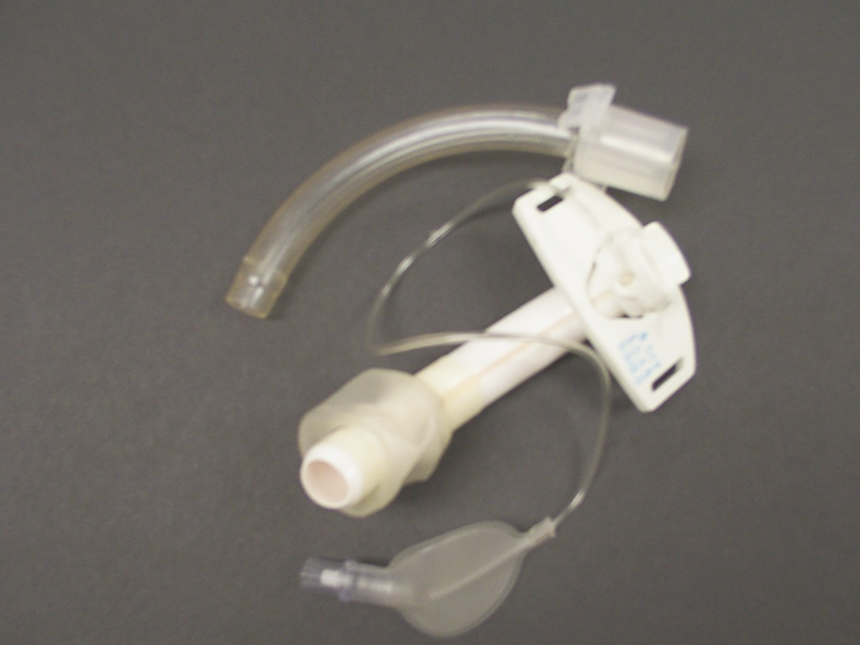

Shiley Disposable Cannula Cuffless Tracheostomy
• Disposable Cannula Cuffless Tracheostomy Tube
- Inner cannula is disposable
• Disposable Cannula cuffless Fenestrated Tracheostomy Tube
- Inner cannula is disposable
- Permits the patient to breathe through upper airway if desired

Shiley Low Pressure Cuffed Tracheostomy Tubes
• Protects the tissue with its cylindrical cuff
• Material used in this trach softens with the patients’ body temperature
Shiley Fenestrated Low pressure Cuff Trachesotomy tube
• allows weaning of the patient from tube by facilitating upper airway breathing

Shiley Cuffless Tracheostomy Tubes
Comes with or without a fenestrated tube. The fenestrated tube is designed for pulmonary hygiene and when used with the decannulation plug, it directs breathing through the upper airway
Tracheostomy Tube Accessories

Shiley Speaking Valve
- Designed for use on alert, awake tracheostomy patients who are able to breathe independently without assisted mechanical ventilation.
- It connects to the tracheostomy tube to direct airflow past the vocal cords to give patients the ability to speak.
- It permits easier vocalization without finger occlusion

Disposable Inner Cannula

- Disposable inner cannula has ‘clips’ or ‘snap lock’ on either ide

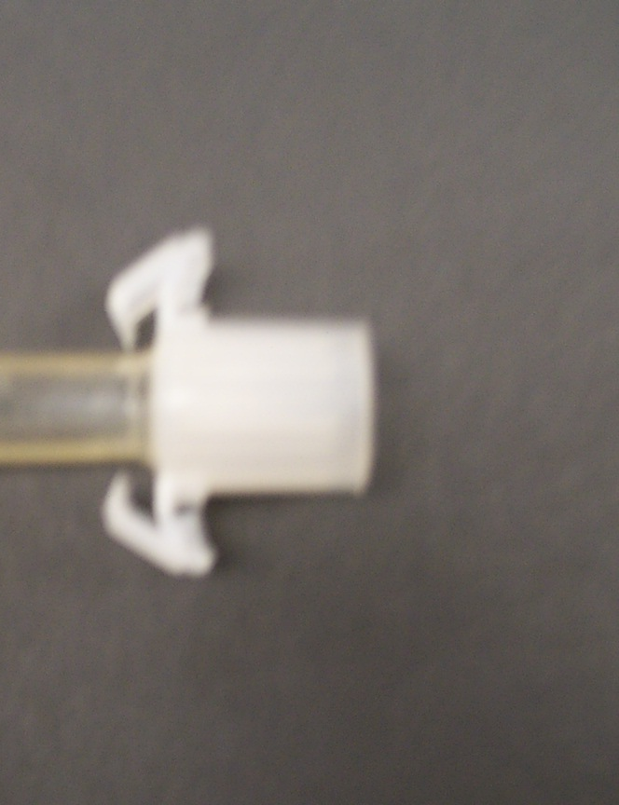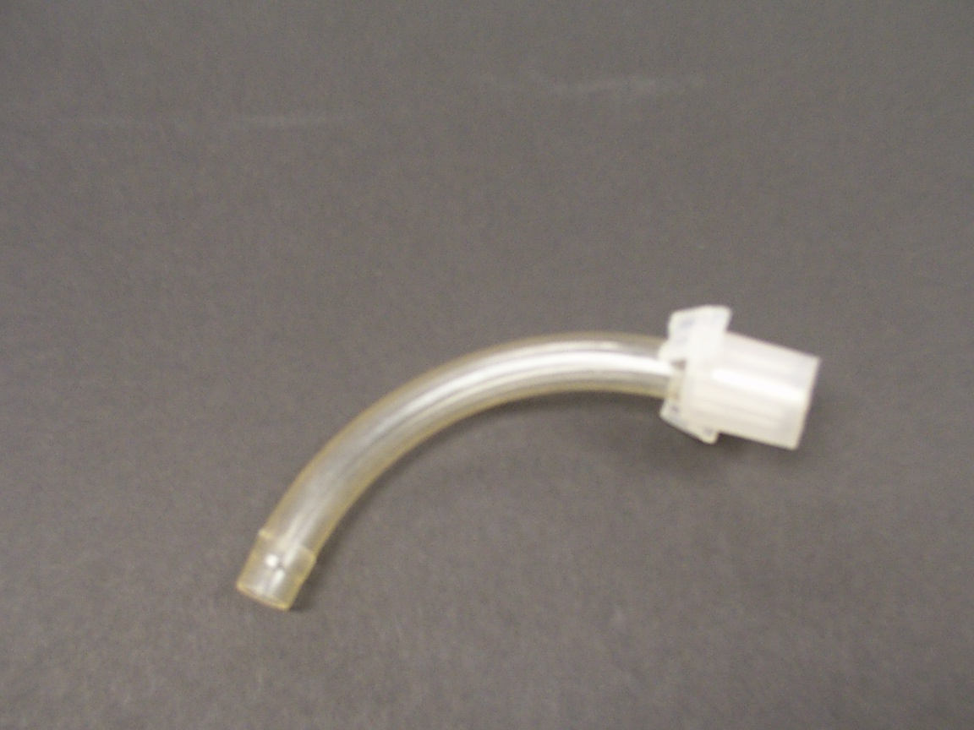

Disposable Decannulation Plug
• Used with the Disposable cannula cuffless Trach tubes
• When snapped into place on the Disposable Cuffless Tube it allows breathing through fenestration and upper airway
• The cuff closes to the proximal end of the tube

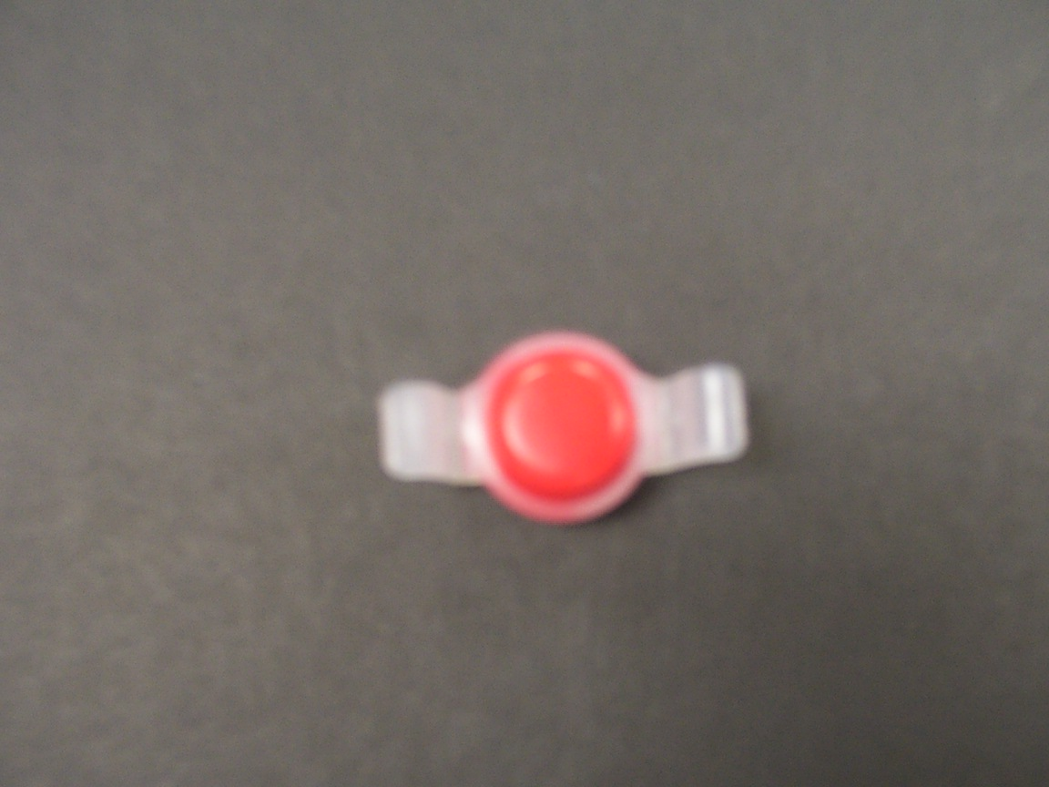

Decannulation Plug
• Connect to the outer cannula of a low pressure cuff tube

Inner Cannula for Low Pressure Cuffed Trach Tube
• Translucent
• No clips thus not disposable
• The twist lock locks into place with the outer cannula. It also permits
connection of ancillary equipment ie ventilator / ambu bag

Think Trach…Think Trach Care
- A tracheostomy is viewed as a foreign body, thus the body responds by producing mucous.
- The trach impairs the natural cililary movement to expel mucous
- Remember that since the upper airway is bypassed the natural protective and hydrating mechanisms are lacking so the patient is at risk for infection. Colonization of the Trachobronchial tree is usually due to inadequate trach care or prolonged tracheostomy. Providing humidification can prevent thick mucous production.
- A stoma less then 48 hrs old has not formed a tracheostomy tract.
- A small amount of bleeding is expected for the first few days following tracheostomy. Bright, frank bleeding or constant oozing is not expected and should not be brought to the attention of the physician or nurse practitioner.

Indications For Suctioning
Artificial airways can interfere with effective coughing and secretion removal. Therefore, periodic suctioning is indicated. Indications for suctioning include:
- Secretions in the trach
- Suspected aspiration of gastric or upper airway secretions
- Auscultation of adventitious lung sounds over the trachea or main stem bronchi or both
- Increase in peak airway pressures when on ventilator
- Increase in respirations or sustained cough or both
- Gradual or sudden decrease in ABG
- Sudden onset of respiratory distress when airway patency is questioned

Suctioning of airways should be done in response to a clinical indication and not on a routine basis. See Nursing Practice policy 1001 for hospital procedure. Remember these points of emphasis:
  - Suctioning a patient is a Sterile procedure
  - Always preoxygenate patient
  - Apply suction for no more then 10 seconds
  - Suction is only applied when withdrawing the catheter out of trachea…never on insertion of catheter
  - Repeat procedure no more then 2 additional times
Complications Related to Suctioning
- Respiratory arrest
- Cardiac arrest
- Cardiac Dysrhythmias
- Hypertension or Hypotension
- Decreases in mixed venous O2 sat
- Increase Intracranial Pressure
- Bronchospasm
- Pulmonary Hemorrhage or bleeding
- Tracheal mucosal damage
  - Epithelial denudement, hyperemia, loss of cilia, edema occurs during suctioning when the tissue is pulled into the catheter tip holes
  - This damage increases risk for infection and bleeding

Signs and Symptoms of Airway Obstruction
- Secretions in the airway
- Inspiratory wheezes
- Expiratory crackles
- Restlessness
- Ineffective coughing
- Decrease level of consciousness
- Decreased breath sounds
- Tachypnea
- Tachycardia or bradycardia
- Cyanosis
- Hypertension of hypotension
- Evaluate SVO2 and SpO2 levels
    - Indicates potential secretions in airway and decreased gas exchange
- Shallow respirations
    - Result from inadequate gas exchange
  - Peak airway pressure on ventilator
    - Increases potential for secretions in airway indicating increased resistance to gas flow

Evaluate …Implement…Document… and Plan Trach Care
The George Washington University Hospital has a Physician Order Set to be utilized for all patients with a Trach. This pre-printed order set is to be transcribed onto the Tracheostomy Procedure Documentation Form.

Tracheostomy Orders : Physician Order Sheet

The physician adds the date and time to the order sheet. The physician identifies the trach type, size and date placed.

There is a list of pre-printed orders, which can be customized by the physician.

The order set is signed by the physician and placed in the chart with the other physician orders.

Any staff trained to transcribe orders may transcribe the orders onto the
‘Tracheostomy Procedure Documentation Form’. The nurse must sign the order form indicating that the orders were transcribed correctly.

Tracheostomy Procedure Documentation Form

Evaluate Every 2 Hours
The patient must be evaluated every 2 hours for need to suction trach tube. Remember that we suction as needed. So to evaluate whether the patient meets criteria for suctioning see the section on Indications for suctioning and S/Sx of Obstruction.

When a patient is suctioned please document the time including description and amount of secretions yielded in the box provided.

Perform Trach Care Every 12 hours
According to hospital policy the Trach Care needs to be done every 12 hours. Trach Care includes changing the inner cannula.

Change the inner Cannula
- GWUH promotes the use of disposable inner cannulas.
  - Remember that disposable inner cannulas have the ‘clips’ on either side
  - If you have a disposable inner cannula then make sure you have the same size and type of inner cannula before discarding the used one
  - Replace the inner cannula
  - Never use Hydrogen Peroxide on a disposable inner cannula as the material will start to decompose.

      - For a patient who presents with a permanent inner cannula
        - Sterile technique is required and the inner cannula is cleaned using ½ hydrogen peroxide and ½ NS mixture
          - H2O2 loosens debris
          - Clean inner cannula with pipe cleaners or brush to remove debris and thick secretions
          - Rinse in NS
          - Never use gauze to dry

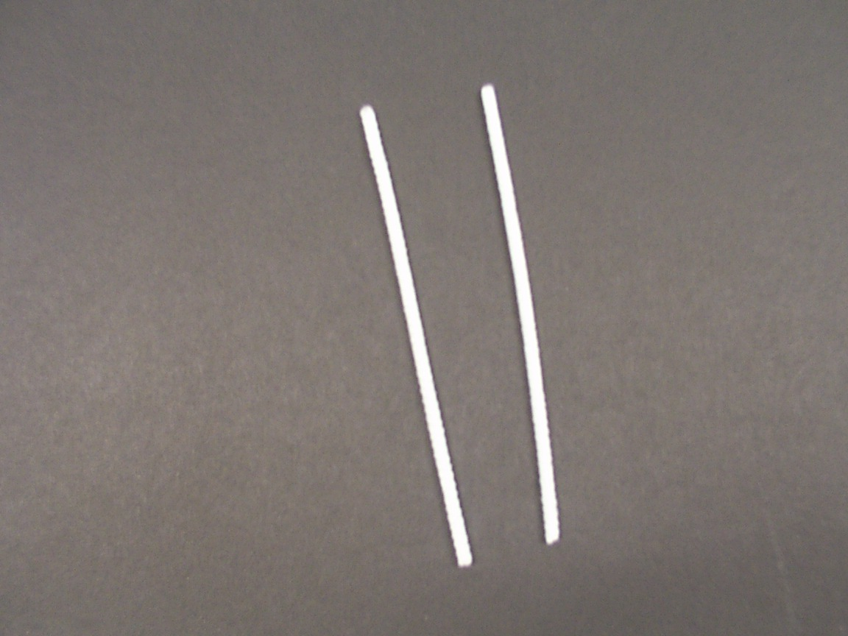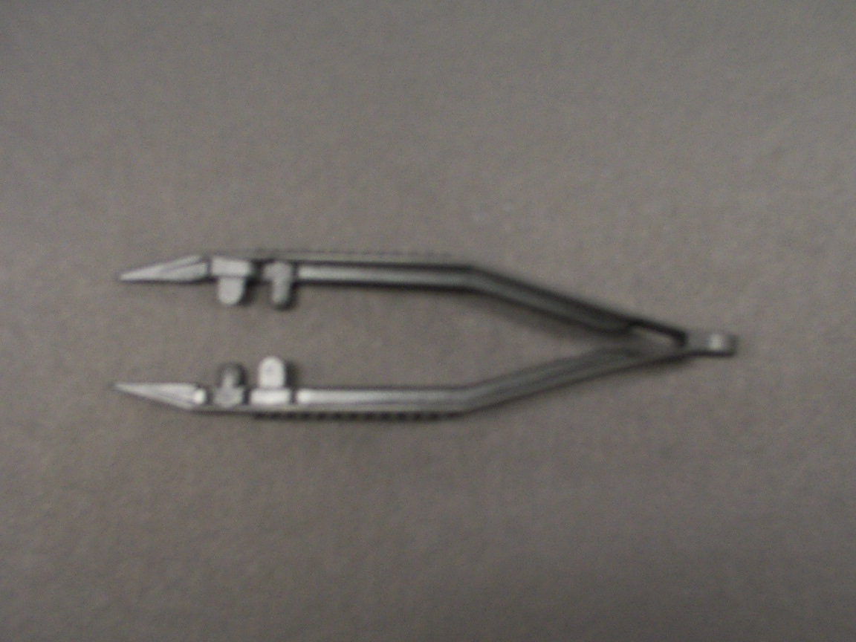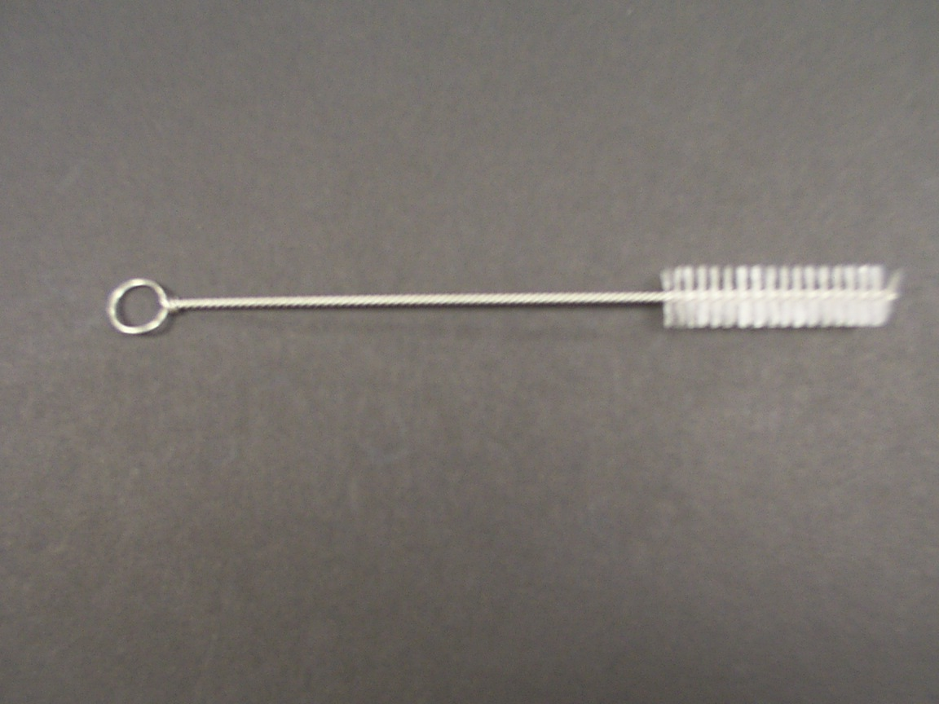

Remove oxygen source from outer cannula to gain access to the opening of the outer cannula and insert inner cannula

Lock inner cannula in place
Reestablish oxygen source

Keep Stoma Clean and Dry
After cleaning or replacing the inner cannula, the outside of the trach needs to be cleaned.
- Moisten swabs and 4 X 4 gauze pads with NS Apply around stoma site, and neck plate removing secretions and debris
- Pat dry the skin area surrounding the stoma site. The dry surface promotes decrease in microorganism growth and skin breakdown
- Apply a clean, precut tracheostomy dressing under faceplate. This promotes absorption from drainage.
  - Never cut a 4X4 gauze pad because the edges fray and provide a potential source for infection

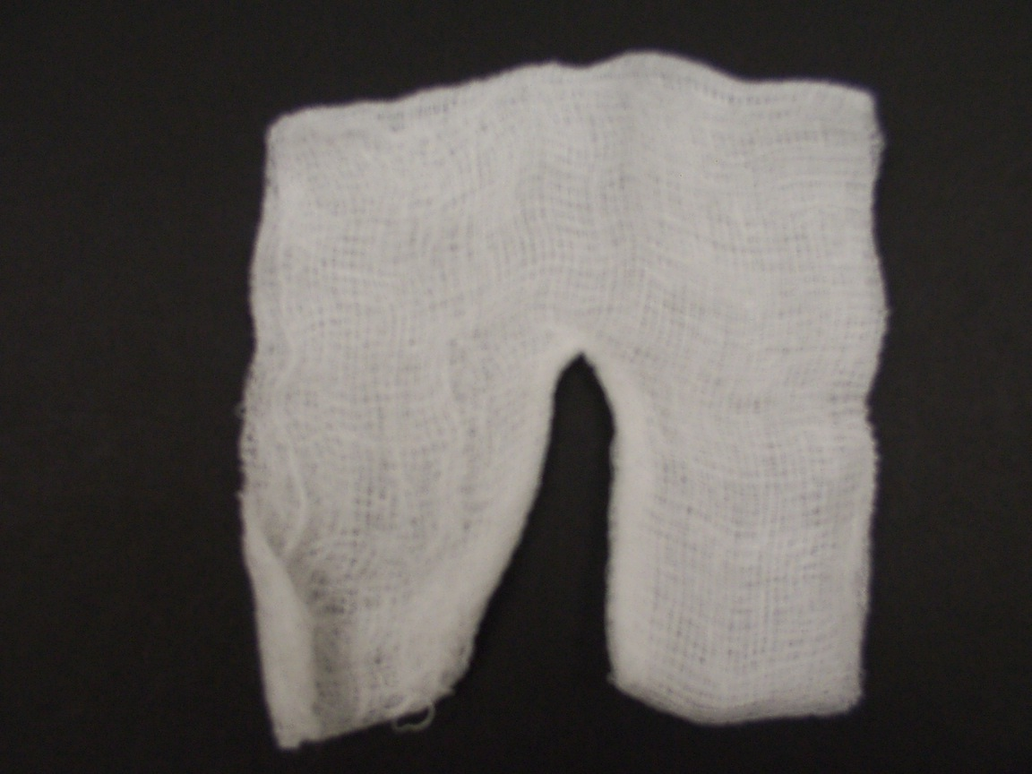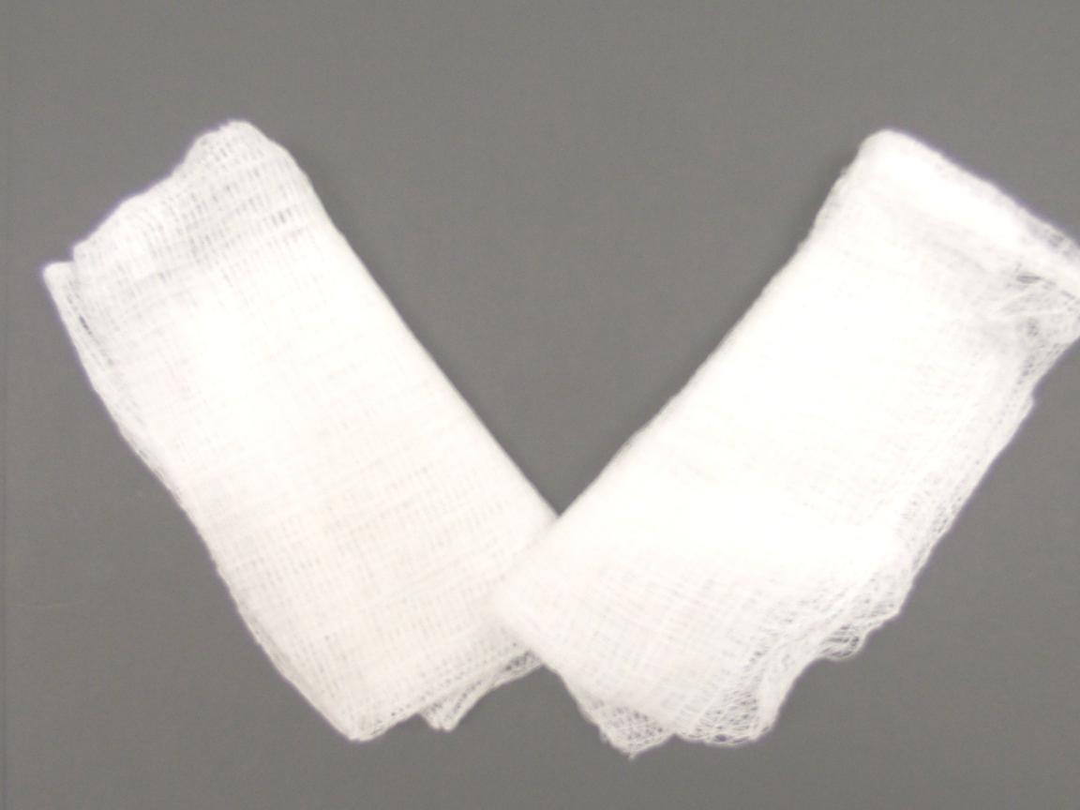

Precut Gauze Do not cut for drsg or May fold 2 4x4’s to mimic a use to dry trach pre-cut gauze dressing

Changing the ties

General Principles
- Always hold one-side of trach in place once untied.
- Change one side at a time.
When using tapers or ties
- Insert one tie end through the faceplate and pull until ½ of the taper is through the eyelet.
- Slide the double tie around the back of the neck and insert through the second eyelet.
- Bring one tie around the neck, pull snug, and tie in a double square knot on the side of the neck where you started.
With that said it is worth mentioning that we have and normally use Velcro Tracheal Ties.

When using Trachesostomy tube Holder ( Velcro )
- These are for single use only. Do not wash.
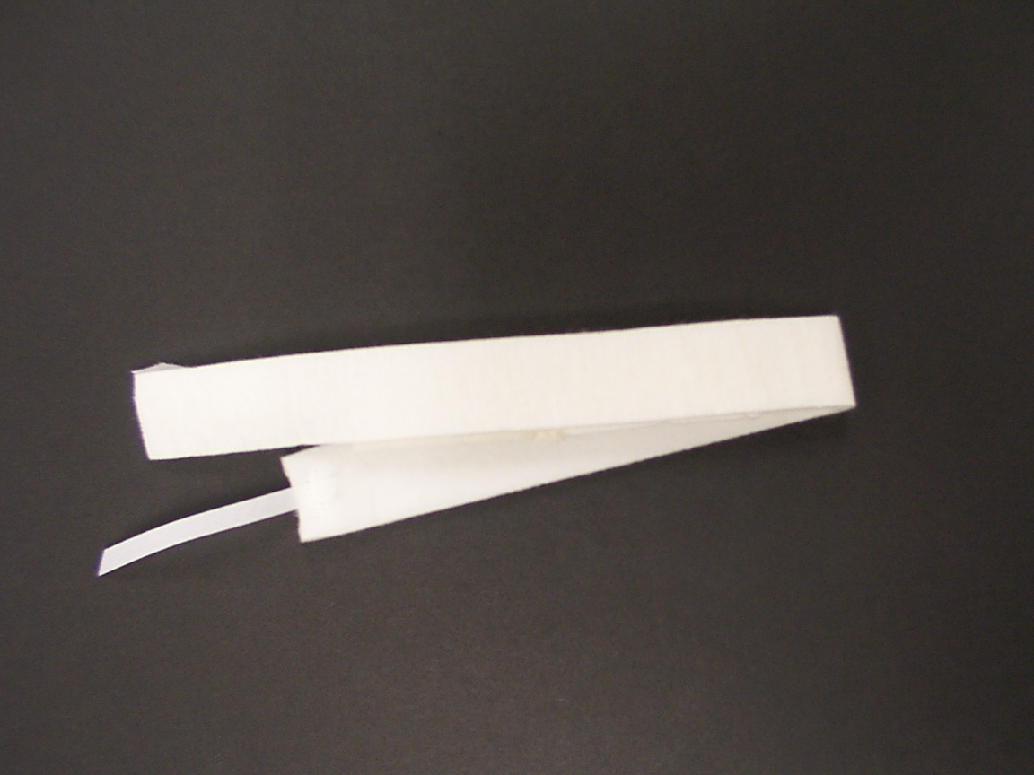
- Thread long narrow fastener tabs through flanges on trach plate
- Bring tabs back over flange and adhere to soft material on the neckband
- Allow a longer loop on the fastener tabs to keep neckband from becoming soiled
- Adjust and secure wide fastener tabs (A) to soft material on neckband (B) for proper length or compression.
- Cut off excess material

Plan to be Prepared

Planning is like an ounce of prevention.
Care of the patient with a trach means ensuring that the airway is patent and that the patient is receiving humidified O2 when ordered.

It also means to ensure that the obturator and same size trach and suction equipment are at the bedside at all times. Therefore, you must document every 12 hours that these items are present at the bedside.
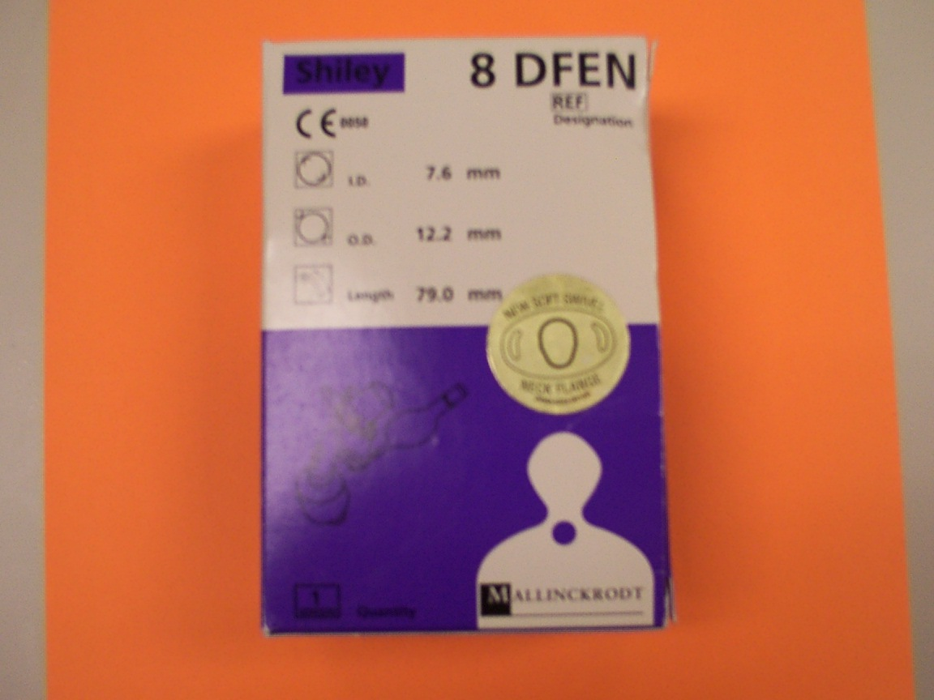

Cuff pressures are to be checked by Respiratory therapy and documented on the same ‘Tracheostomy Procedure Documentation Form’ every 8 hours.
If a patient is using a speaking valve, the cuff must be deflated. If you deflate the cuff, note how much air was removed in the syringe and when inflating only add the same amount. You cannot visually tell how much the cuff pressure is by looking at the pilot balloon.
Whenever you have reason for concern please call Respiratory to check the cuff pressure.

Always document the time that you deflated or inflated the cuff.

Education

Initiate and document education related to tracheostomy and tracheostomy care in the computer system.

This is part of the physician orders. A bullet is posted on the bottom of the Documentation form to serve as a reminder.

Education must include who was taught, readiness to learn, barriers to learning, learning needs, content taught, how it was taught and the patients/families response. Indicate if follow-up action is needed.

Terminology

Cannula, Inner: Removable inner tube that acts as a passageway for airflow and secretion removal

Cannula, Outer: The external tube that is inserted into the trachea through a surgical or percutaneous opening. It provides an artificial passage for breathing and may house an inner cannula

Cap: The white 15mm cap is used only with the Fenestrated (hole) inner cannula. ( 15 mm Connector). The cap will block all expired and inspired air through the tube. This allows breathing to be forced through the mouth and nose, allowing speech.

Cartilage: Tough, elastic tissue forming parts of the trachea.

Connector, 15 mm: A part of the inner cannula that secures the outer cannula to the inner cannula. This adapts to respiratory equipment like a ventilator

Connector, Low A part of the inner cannula designed to reduce tube protrusion at the Profile neck. This is not compatible with respiratory equipment

Connector, Snap- Part of the inner cannula which is disposed of after each use.
Lock Used fro respiratory equipment and to secure the inner cannula to the outer cannula.

Connector, Twist- a 15 mm connector that attaches the inner cannula of the Lock tracheostomy tube to the outer cannula by twisting in place.

Cuff: Balloon – like component, that when inflated with air, acts as a seal to eliminate or reduce airflow through the mouth and nose. With the cuff inflated, breathing will be directed through the tracheostomy tube.

Cuffed Tube: A tracheostomy tube that has a cuff which, when inflated with air, acts as a seal to eliminate or reduce airflow through the mouth and nose. With an inflated cuff, you will breath only through your tracheostomy tube.

Cuffless Tube: A tracheostomy tube without a cuff that allows airflow through the mouth, nose and trachesostomy.

Decannulation Plug: Also known as DCP ( decannulation plug) or DDCP (disposable decannulation plug)
DCP attaches to the outer cannula of a fenestrated tracheostomy tube when the inner cannula has been removed. Blocks airflow through the tracheostomy tube and directs breathing through the nose and mouth

Deflation: Collapse by removing air or gas

DIC: Disposable inner cannula

Encrustation: Hardened build-up of mucous formations

Fenestrated Inner Removable inner tube with a hole (fenestration) that permits air to Cannula: pass through the outer tube hole(s), (fenestration) up past the vocal cords and exit the mouth and nose, allowing speech. It can be easily identified by a green 15 mm connector and hole, in the curved part of the body of the tube. It should not be used with mechanical ventilation.

Fenestration: A hole(s) in the cannula that allows air to be directed past the vocal cords and through the mouth and nose.

Inflation line: Thin plastic line connected to cuff, pilot balloon and luer valve, which allows the cuff to be filled with air

P-V Gauge: The digital P-V Gauge is a precision electronic pressure measurement device that helps accurately set and monitor cuff pressure to help minimize trachea damage

Pilot Ballon: Plastic sac-like component connected to the inflation line and Luer Valve, which acts as an indicator for the amount of air pressure within the cuff

Single Use Only For one-time use only. Do not re-clean, resterilize or re-use

SIC: Spare Inner Cannula

Swivel Neck Plate: The swivel neck plate provides information about the size and type of tube. The neck plate with the tracheostomy ties properly attached helps to secure the tube to the patient’s neck. The swivel assists the tube to be positioned properly in the trachea

Tissue Ingrowth: Growth of tissue into the hole(s) (fenestrations) of a tracheostomy tube

Tracheal Stoma: An opening in the neck that forms an additional path for airflow to the lungs, usually bypassing the mouth and nose

Tracheal Wall: Mucosal lining of the trachea

Tracheostomy: Creation of a surgical opening through the lower neck and trachea to make breathing easier

Tracheostomy tube: An artificial breathing tube inserted into the surgical opening in the trachea

Tracheotomy: Surgical incision into the trachea

References: Carlson; Lynn-McHale: AACN Procedure Manual for Critical Care

Dale Medical Products, Tracheostomy Tube Holder with Exclusive Fastner Tabs

Mallinckrodt Medical; Tracheostomy Tube, Adult Home Care Guide, shiley Tracheostomy Products

Mosby: Medical – Surgical Nursing Concepts and Clinical Practices

SIMS Portex; Tracheostomy Care Handbook: a guide for the Health Care Provider

Tyco Healthcare; A Quick Reference Guide to Shiley Tracheostomy Products

